Project Design Phase-II Technology Architecture

|  |  |
| --- | --- |
| Date | 28 October 2022 |
| Team ID | PNT2022TMID40213 |
| Project Name | Industry-Specific intelligent Fire Management System |
| Maximum Marks | 4 Marks |

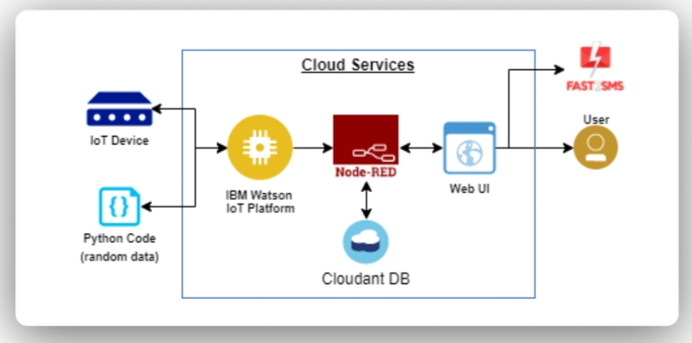

Architecture and Data flow of the IOT Based Industry - specific Fire Management System

Fire monitoring and control system

Intelligent fire detection and mitigation system safe from fire

IoT based Fire monitoring and Alerting System

Smart city IoT based weather monitor system

|  |  |  |  |  |
| --- | --- | --- | --- | --- |
| IoT based fire alarming and authentic ation  system | |  | Advanced IoT based security alert system for smart home | |
|  |  | | |  |
| Automatic fire detection and alert | | | Intruder detection and image capture | |

Detects fire and provides the location of fire

Transmission of a sensor values to a webserver

Techniques to minimize fire hazards and better evacuation plans